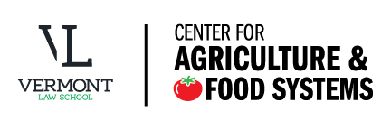
Legal Fellow – Center for Agriculture and Food Systems

The Legal Fellow at the Center for Agriculture and Food Systems (CAFS) will work with faculty, staff, and students on legal projects and initiatives, helping to oversee and implement grant-funded legal and policy projects to support sustainable food and agriculture. CAFS initiatives include the Healthy Food Policy Project and the Farm to School State Legislative Survey, among others. The Legal Fellow develops novel legal tools to improve food and agriculture; translates those tools for broad use (e.g., through social media, web resources, and in-person trainings); supervises students; conducts outreach to local, regional, and national organizations to create strategic partnerships that amplify our progressive work; and helps to develop funding sources. This is a two-year position, with the second year contingent on funding availability and on performance.

Qualifications
- Bar Licensure (VT Bar a plus, but not required)
- A demonstrated commitment to public interest work – a background in food and agriculture is desirable but not required
- Excellent legal analysis, research, and writing
- High degree of professionalism in all aspects of lawyering
- Strong interpersonal skills
- Creativity and flexibility in approaching and solving problems

For more information on this and other positions, please visit our website at http://www.vermontlaw.edu/community/about-vls/employment-opportunities.

Apply via the link above or send a resume and cover letter with salary requirements to Human Resources, Vermont Law School, P.O. Box 96, South Royalton, VT 05068 or to cbrackett@vermontlaw.edu.

Vermont Law School is an equal opportunity employer committed to diversity in our workforce.

